Final Project

For the map itself I used D3 to make a choropleth map that represented the percentage of adults age 25 and older in the United States. Who obtained a bachelor's degree or higher. I separated it by county and into 4 distinct classes: Less than 15%, 15% to 30%, 30% to 45%, and More than 45%. Each class had its own color representation from red, orange, light green, and green. I also created a legend, with D3 as well, so users can easily interpret what the colors mean and what percentage of adults completed a bachelors or higher.

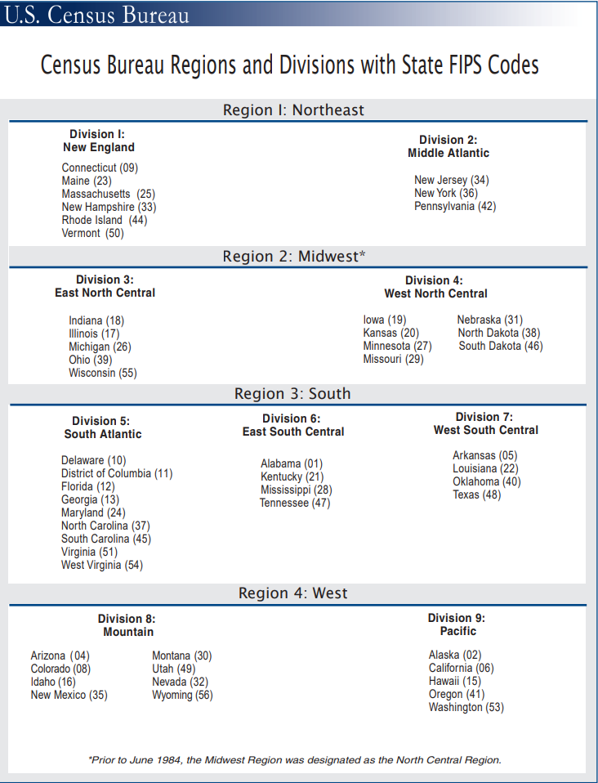I chose to make a static table showcasing the education level for the whole United States and the four main regions with **Leaflet**?. That breakup the vast area of this country. For the data I downloaded the csv file of Educational attainment for the U.S., States, and counties, 1970-2019 from the USDA Website. It contained, by state and county, the percentage and number of people who obtained a certain level of education. From completed less than high school to completing a bachelors or more. Which I whittled down to only the information I needed. Which was percent of adults who completed a bachelors or more for every state and the United States as whole.